Use case

1.Find how many ‘likes’ can the most popular ins post got in our database (get maximum number of like_count in ins_post)

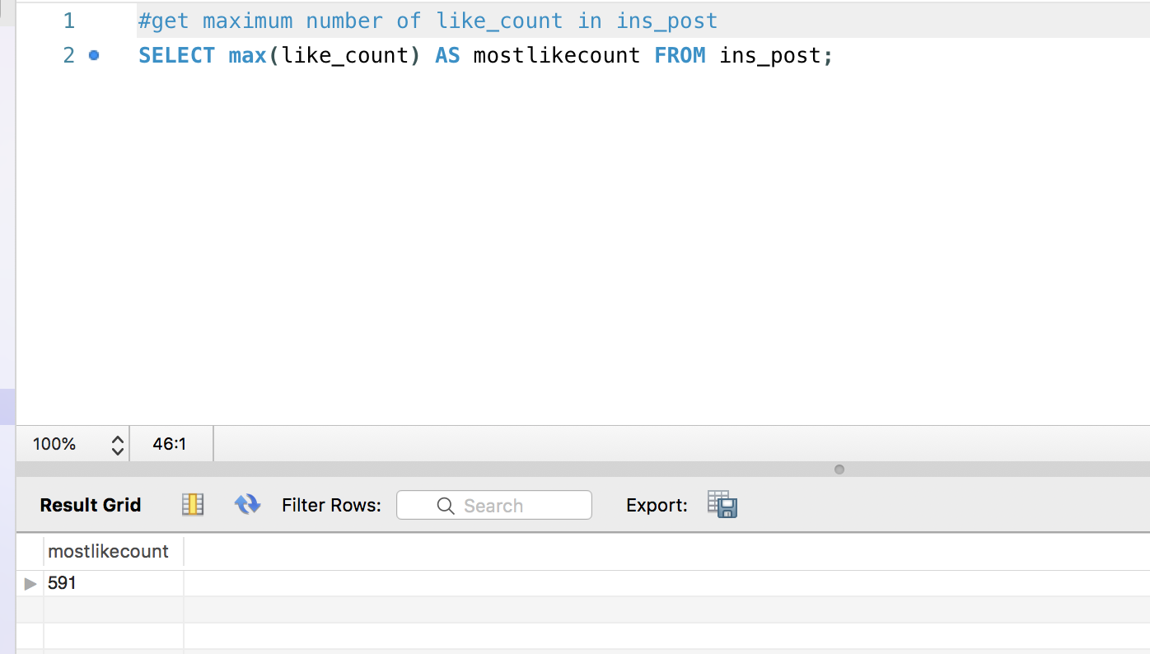

2.Find all movies produced by a specific director:

(his/her new movie on the left, his/her old movie on the right)

SELECT new_movie.title,old_movie_final.movie_title FROM new_movie,old_movie_final WHERE new_movie.director LIKE 'Tim Burton' OR old_movie_final.director_name LIKE 'Tim Burton'

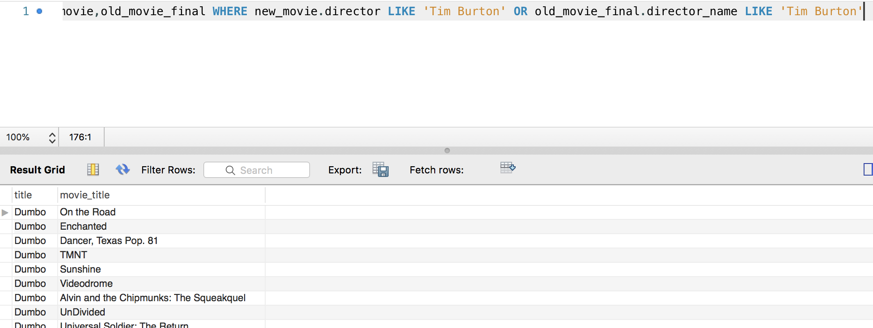

3. get total number of like_count and comments_count

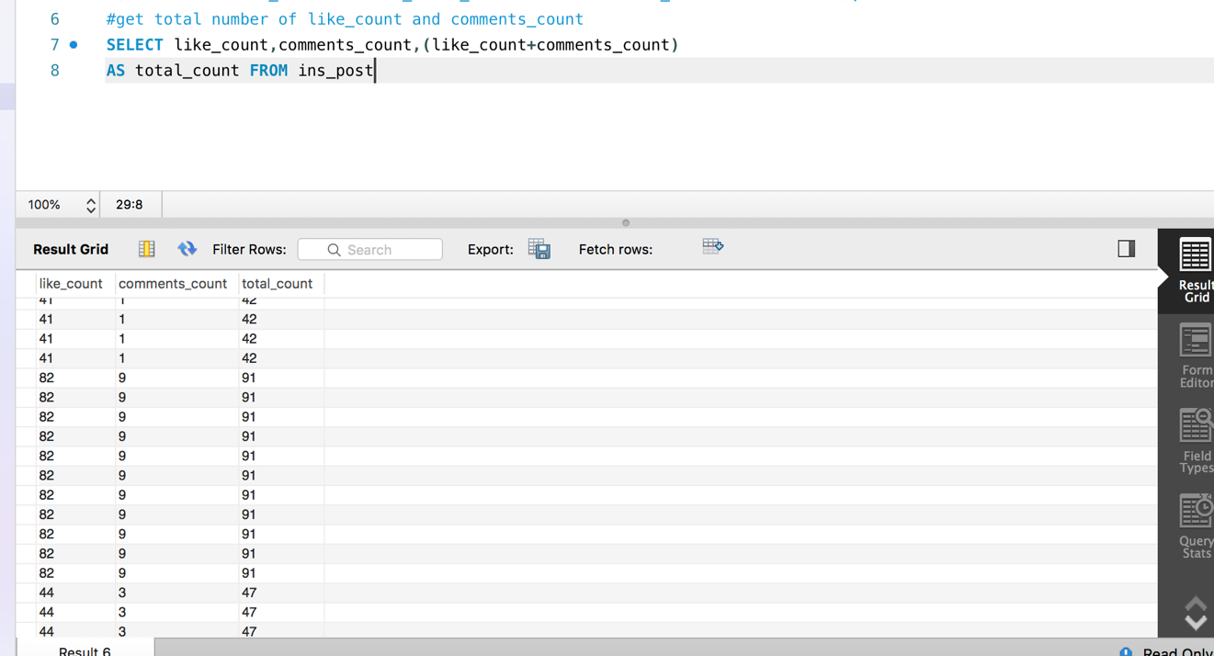

4.get hashtags in ins_post that runtime 10%

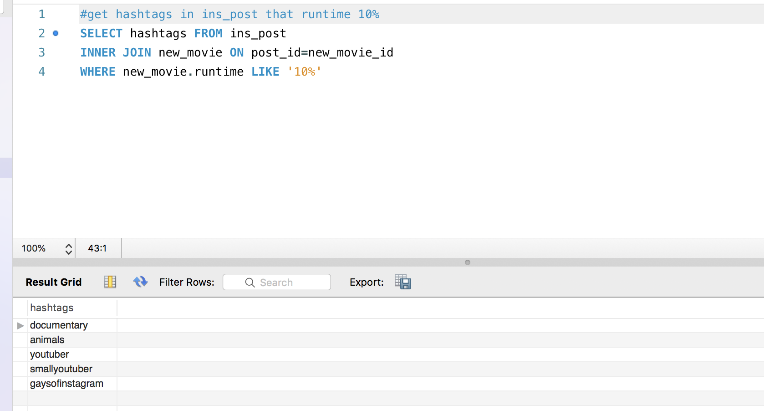

5.#get movie_title that actor name start with Ta%

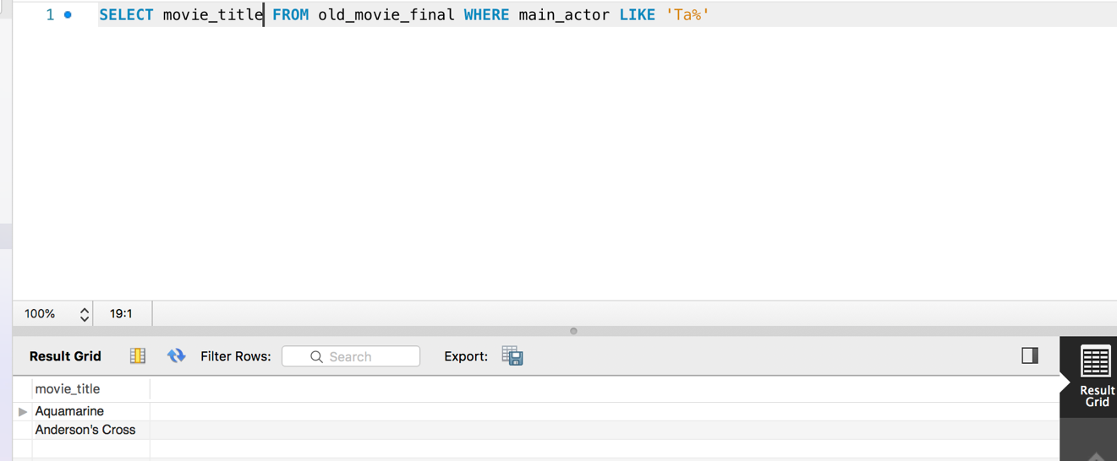

6.Find all old Drama movies by joining genre table and old movie table

SELECT movie_title,genre FROM genre_recommend INNER JOIN old_movie_final ON old_movie_final.genre_id=genre_recommend.genre_id WHERE genre_recommend.genre LIKE 'Drama'

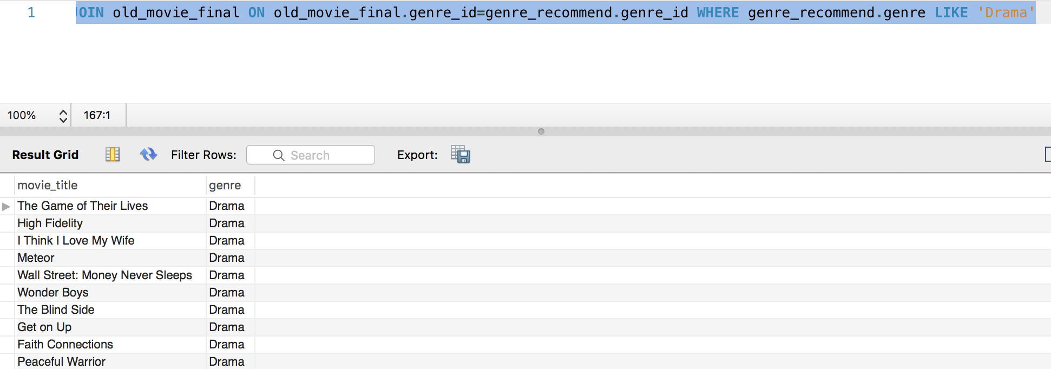

7.Find the running time for different genre by joining 2 tables

SELECT genre_recommend.genre,runtime FROM genre_recommend INNER JOIN new_movie ON new_movie.new_movie_id=genre_recommend.new_movie_id

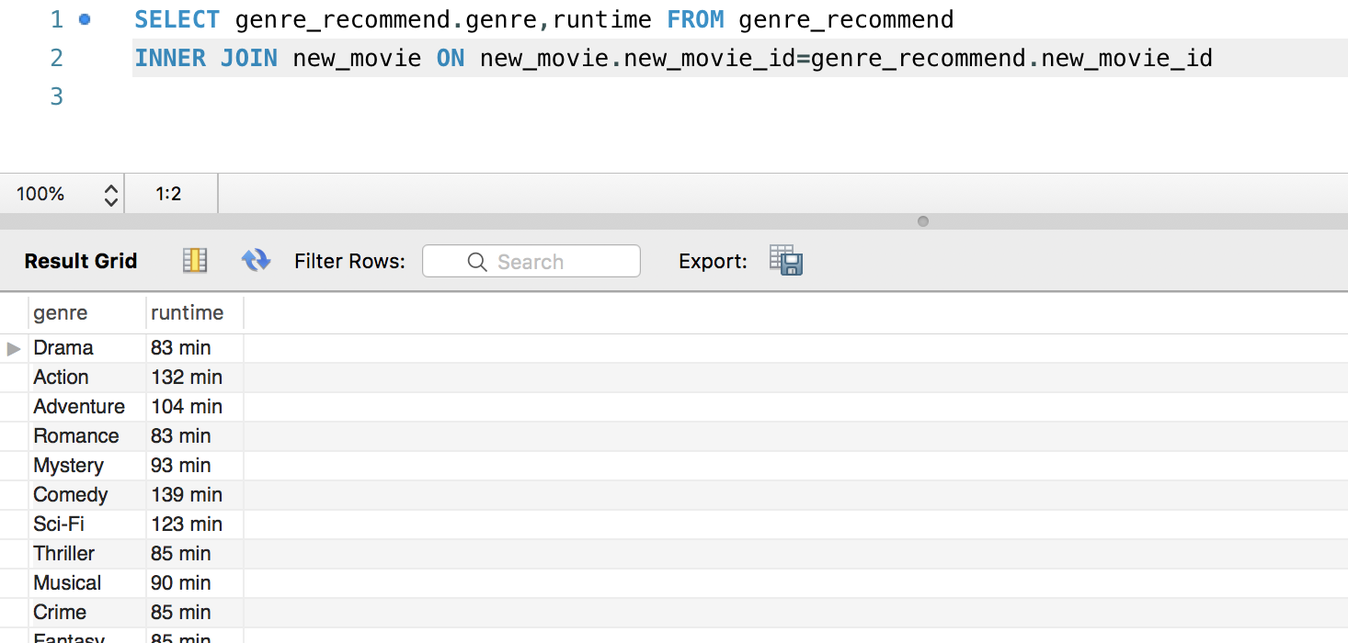

8. find actors of in-theater movies and find what movie they have joined before by joining 3 tables

SELECT new_movie.title, old_movie_final.main_actor, old_movie_final.movie_title FROM old_movie_final,new_movie,genre_recommend WHERE new_movie.new_movie_id = genre_recommend.new_movie_id AND genre_recommend.genre_id = old_movie_final.genre_id

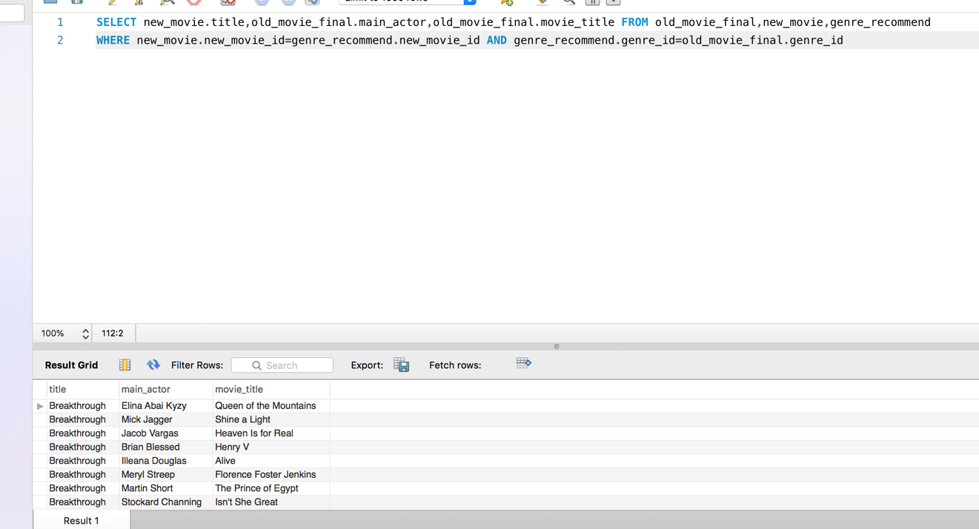

9. Find the most popular hashtag, show them in descrete order

SELECT hashtags,sum(retweet_count) FROM news_trend GROUP BY hashtags ORDER BY sum(retweet_count) DESC

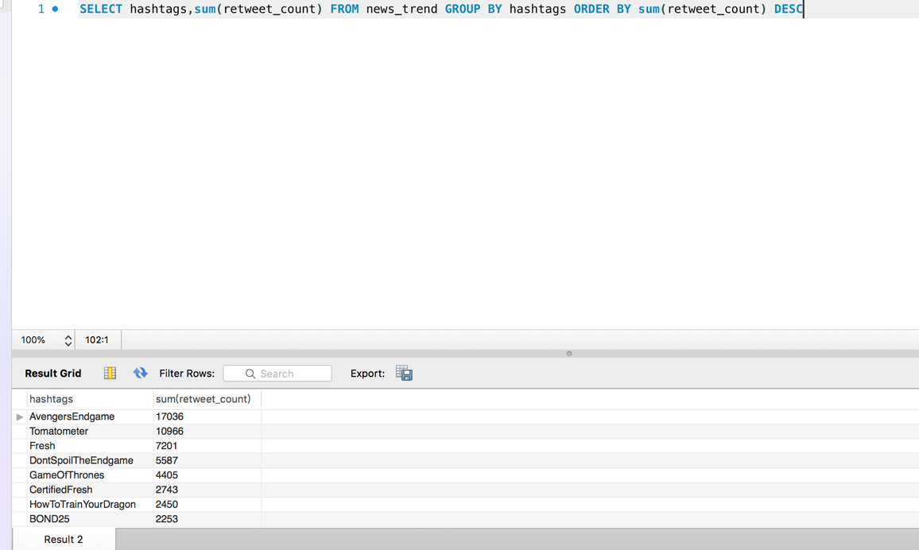

10. The most popular movies

SELECT movie_title,sum(retweet_count) FROM title_hashtags,new_movie,news_trend WHERE title_hashtags.movie_title=new_movie.title AND title_hashtags.hashtag=news_trend.hashtags

GROUP BY movie_title. ORDER BY sum(retweet_count) DESC

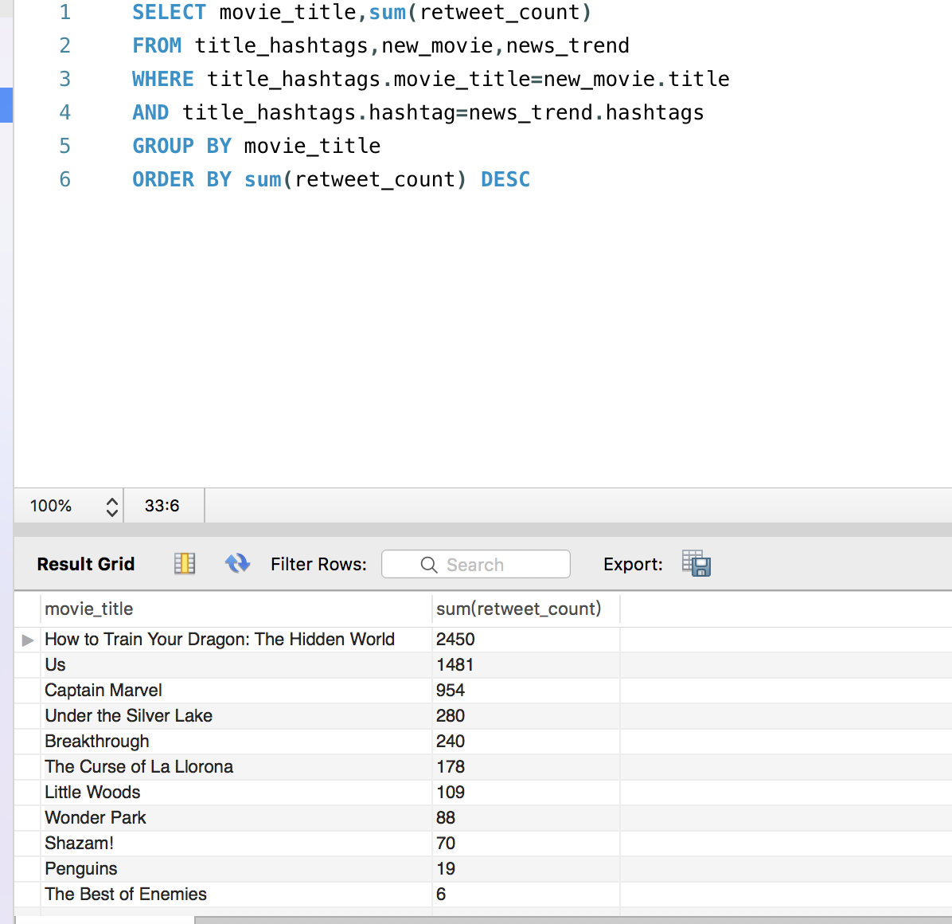

Answer questions

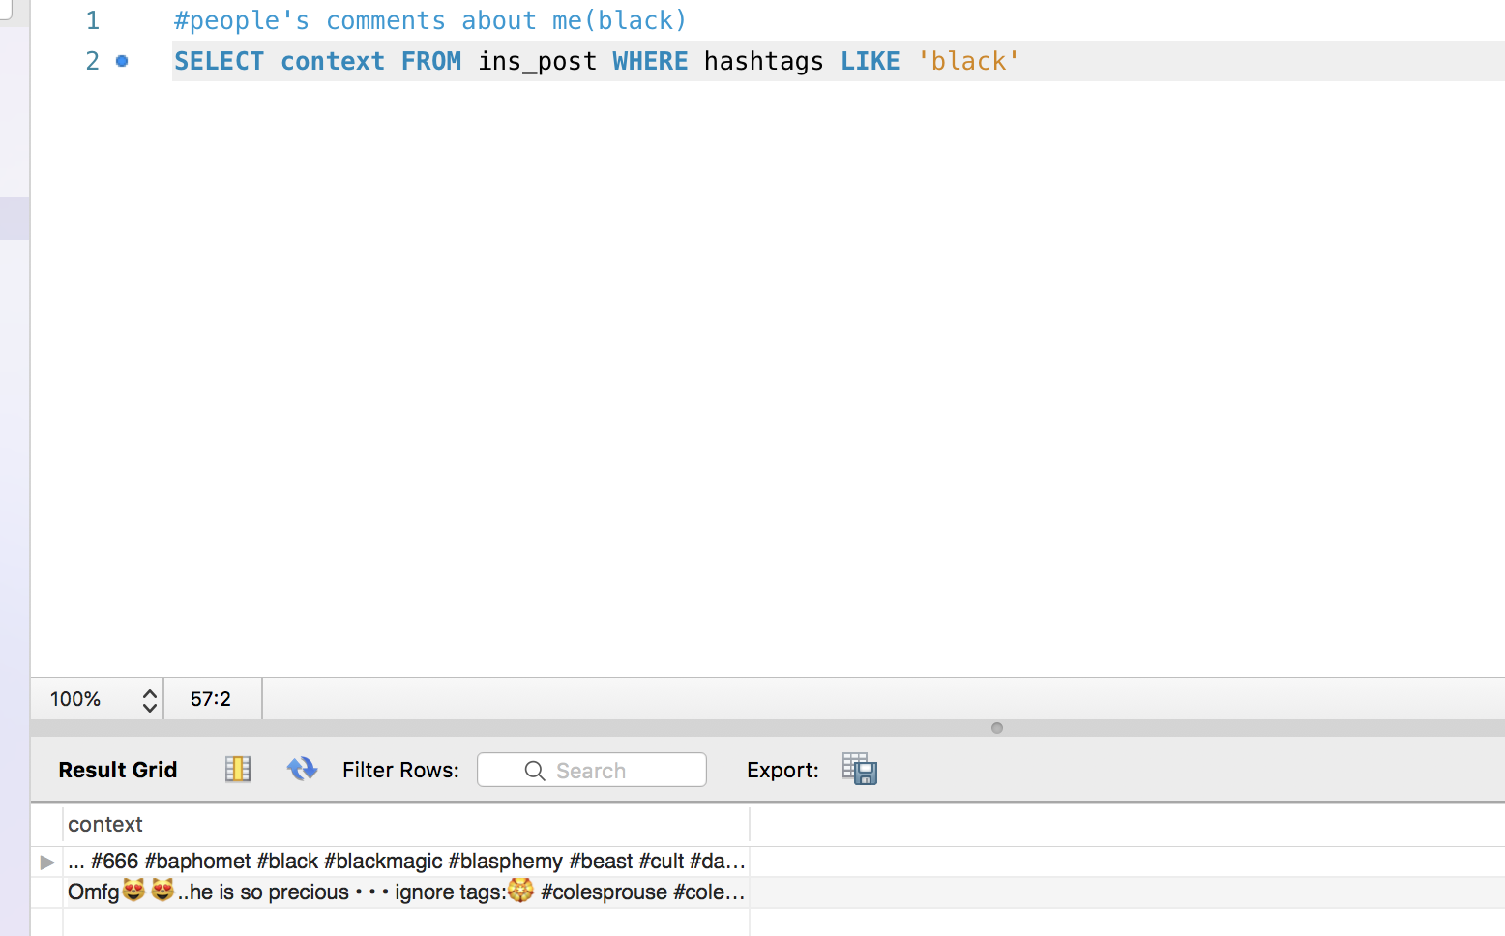1.What are people saying about me (somebody)?

2.How viral are my post?

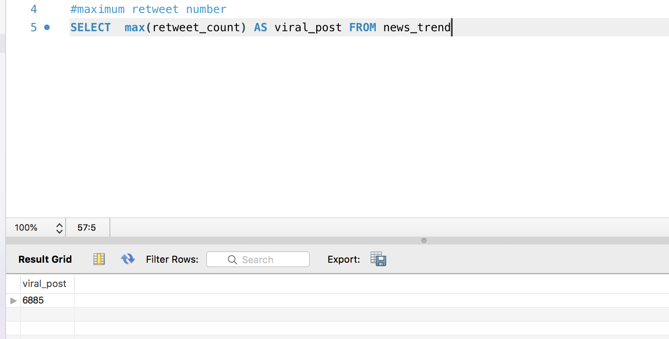6885 retweet, so viral!!

3.What posts are likely to be interesting to me?

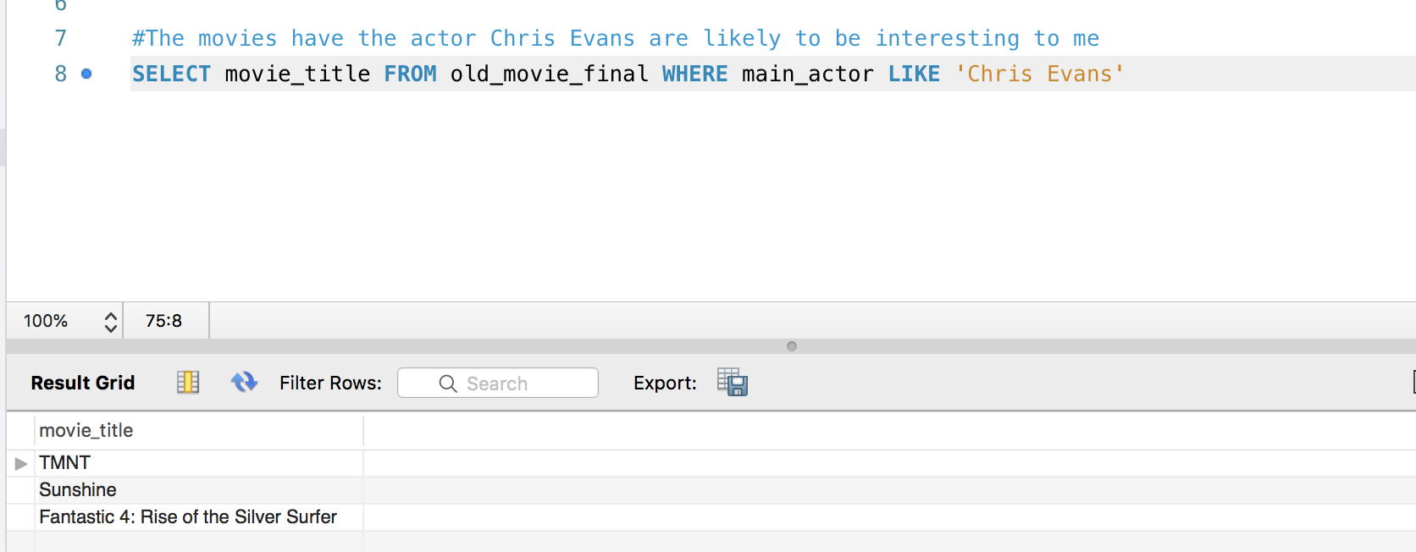

4.What posts are like mine?

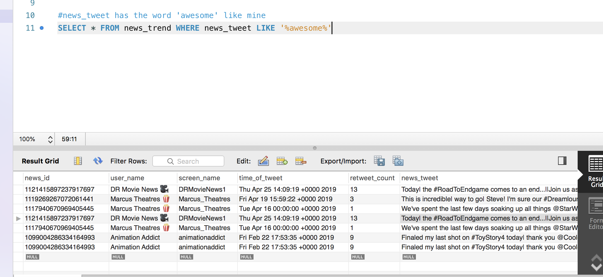

5.What users post like me?

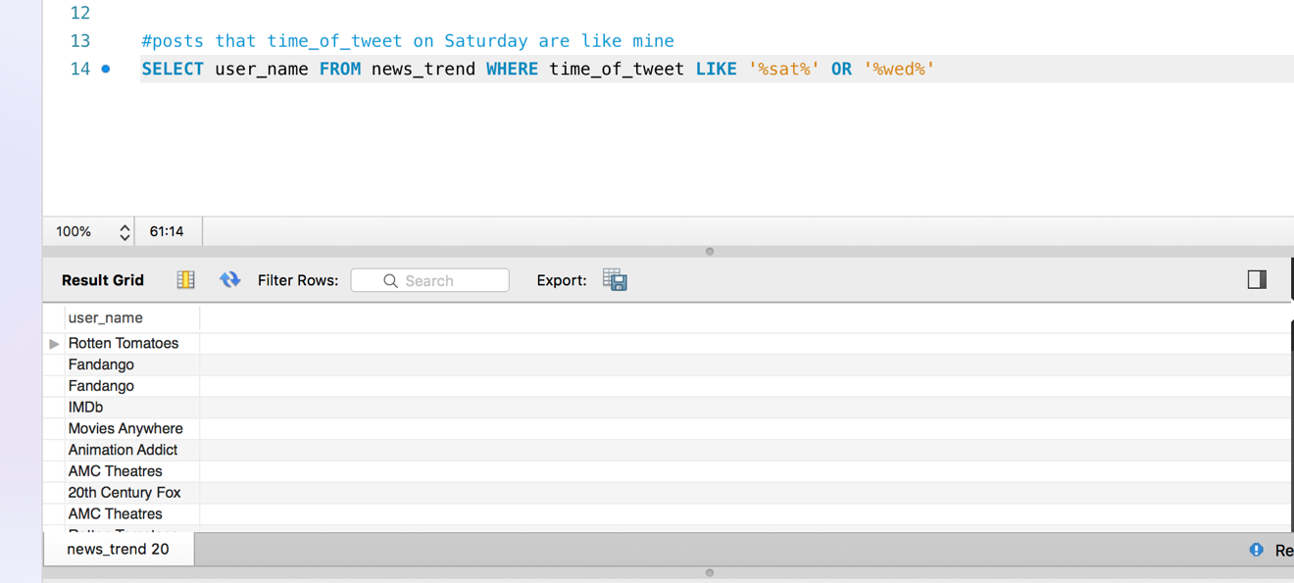

6.Who should I be following?

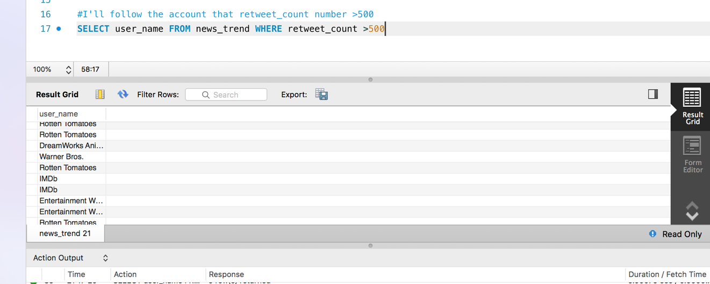

7.What topics are trending in my domain?

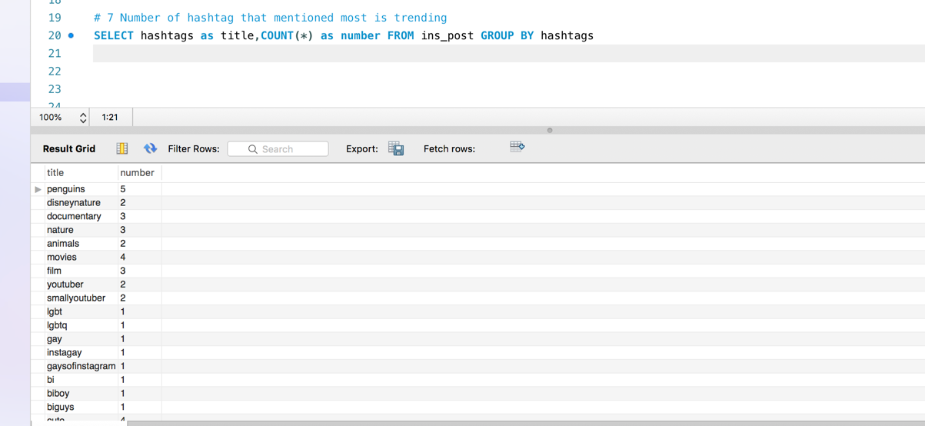

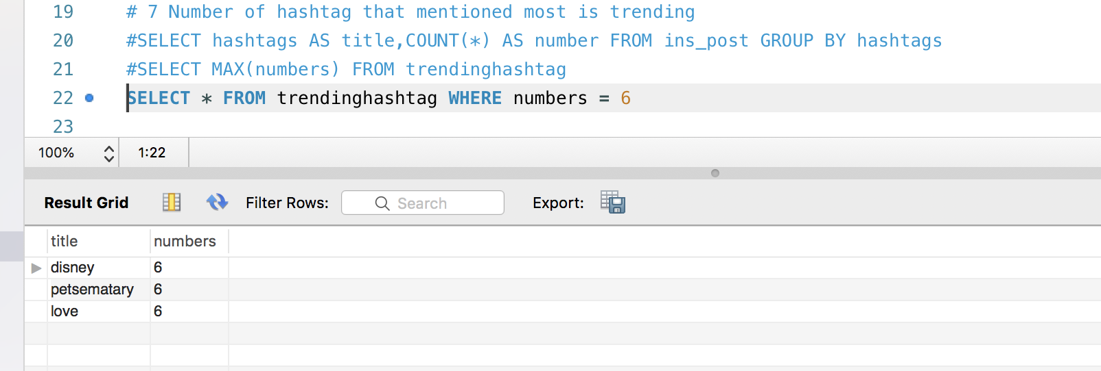

8.What keywords/hashtags should I add to my post?

SELECT title,hashtag,retweet_count FROM title_hashtags,new_movie,news_trend

WHERE title_hashtags.movie_title=new_movie.titleANDtitle_hashtags.hashtag=news_trend.hashtags

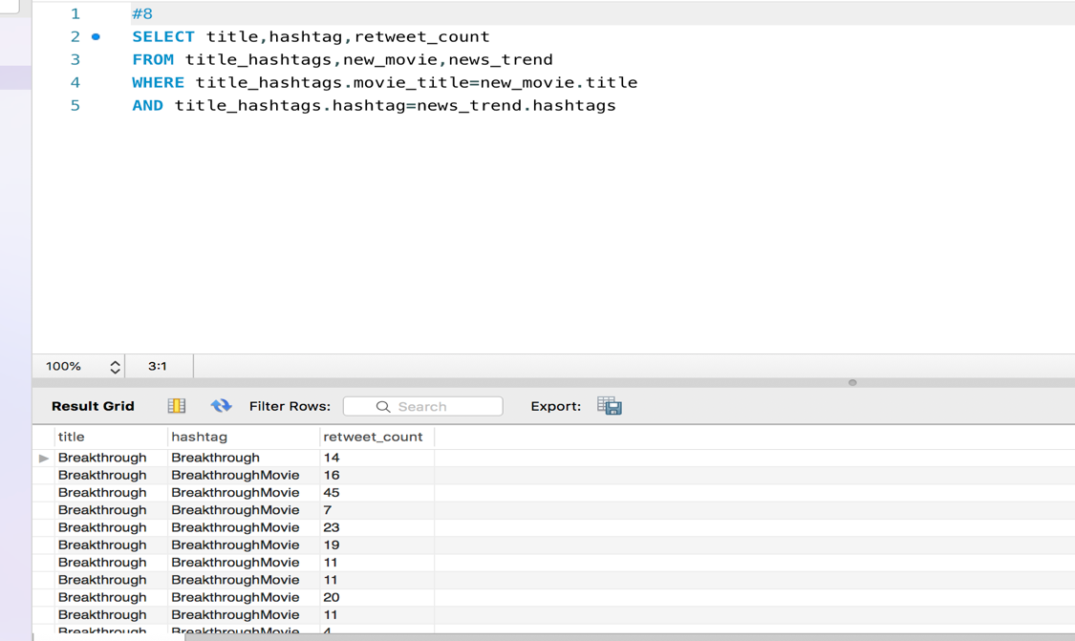

9.Should I follow somebody back?

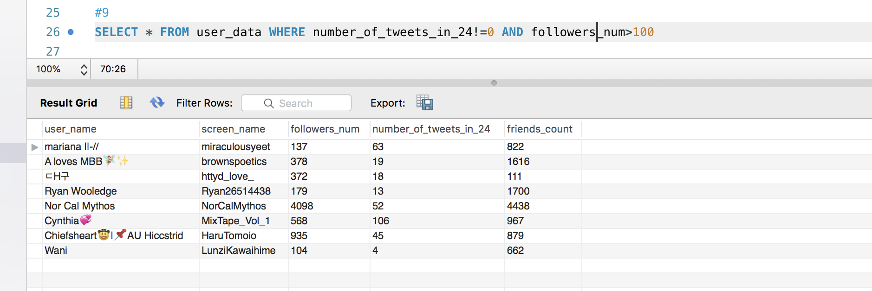

Function

1.get average number of retweet

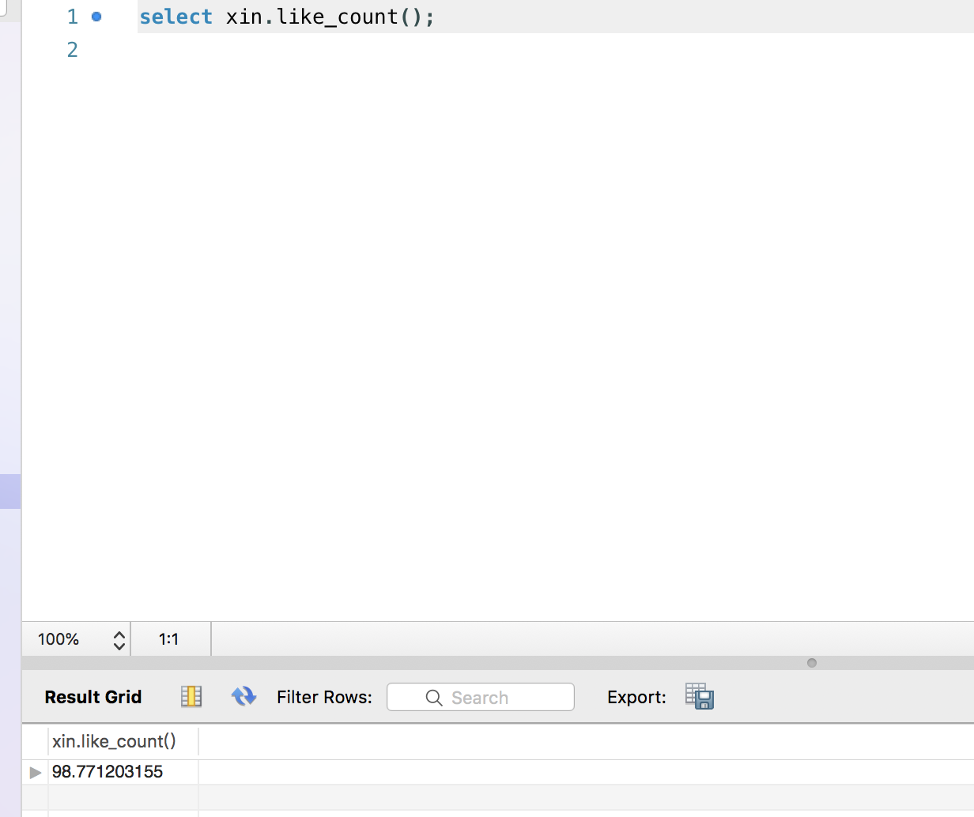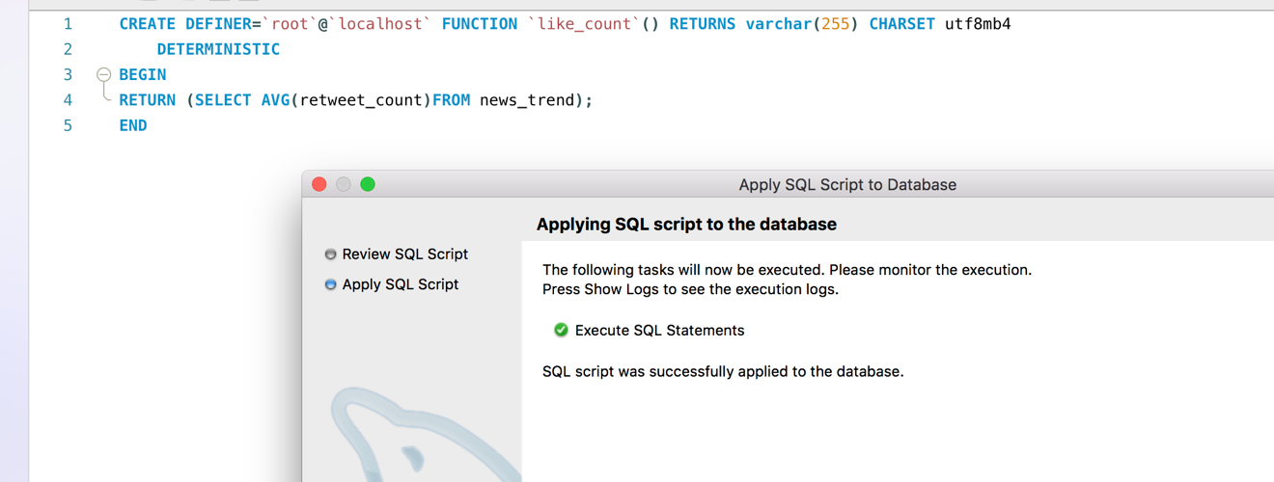

2.Sum of retweet_count by search user_name

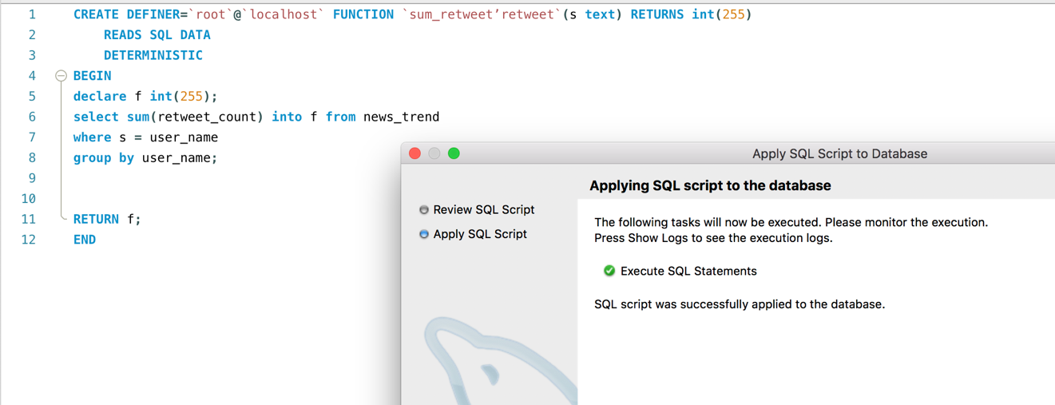

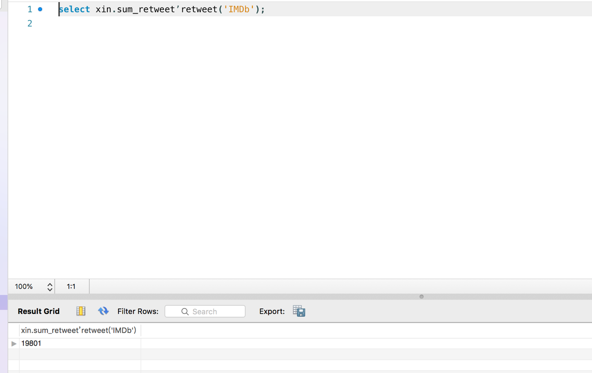

3. number of count_id when user_name is IMDb

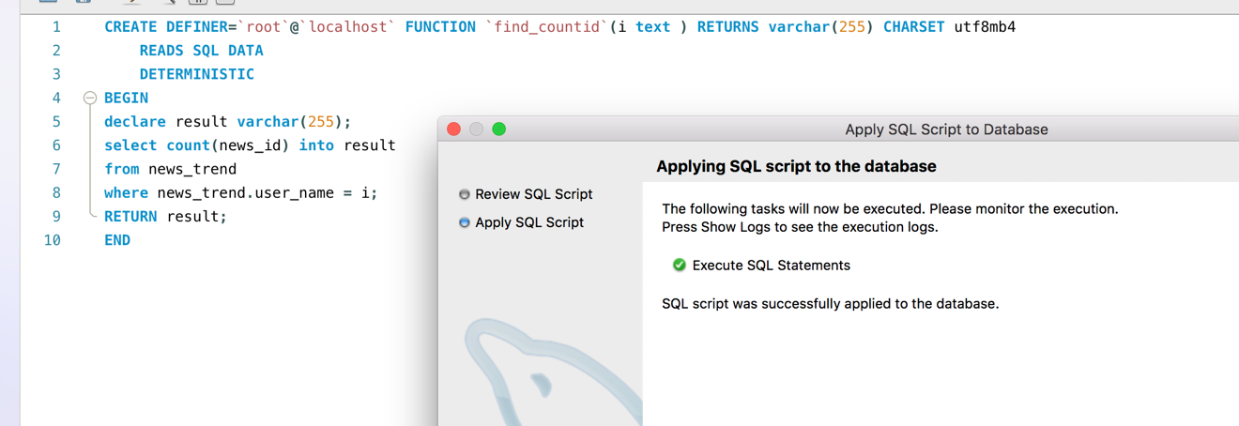

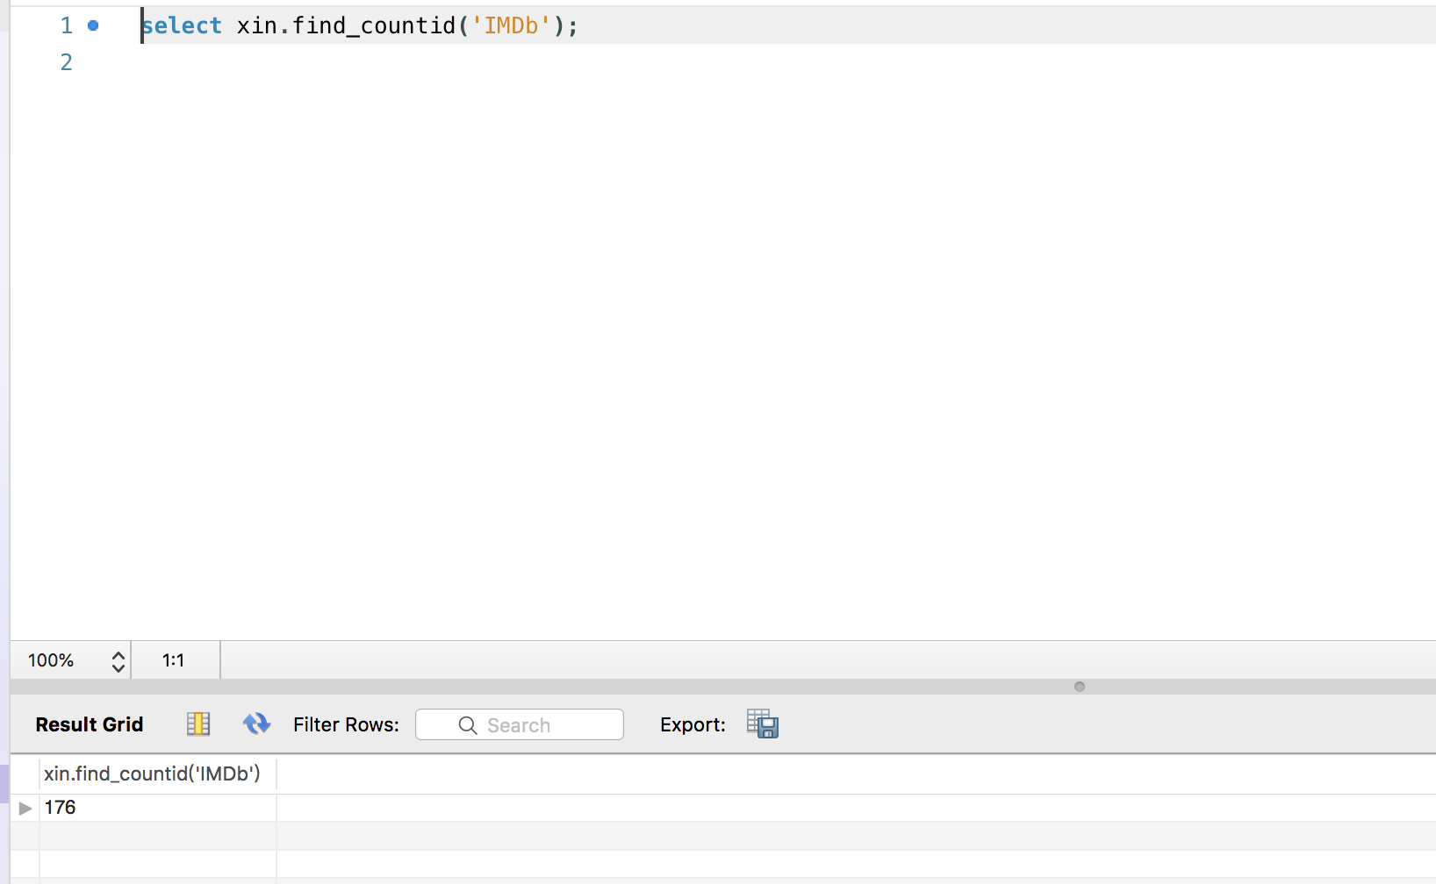

4. class of retweet_count

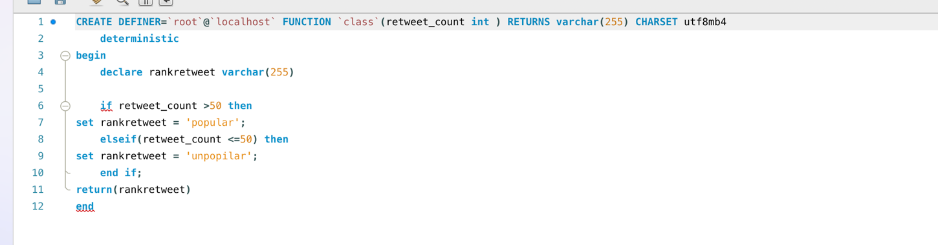

**Views**

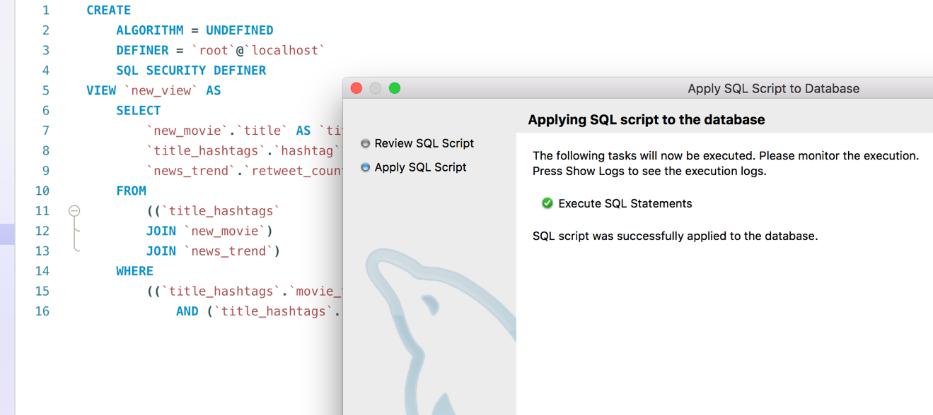View1

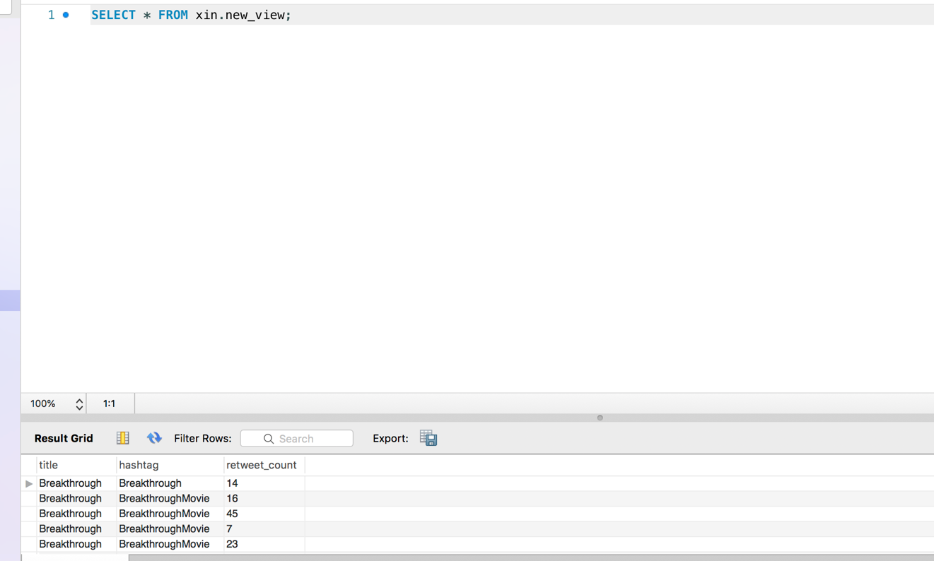

View2

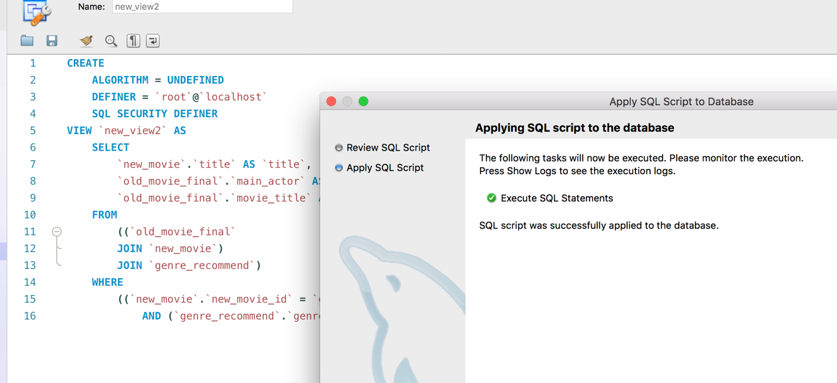

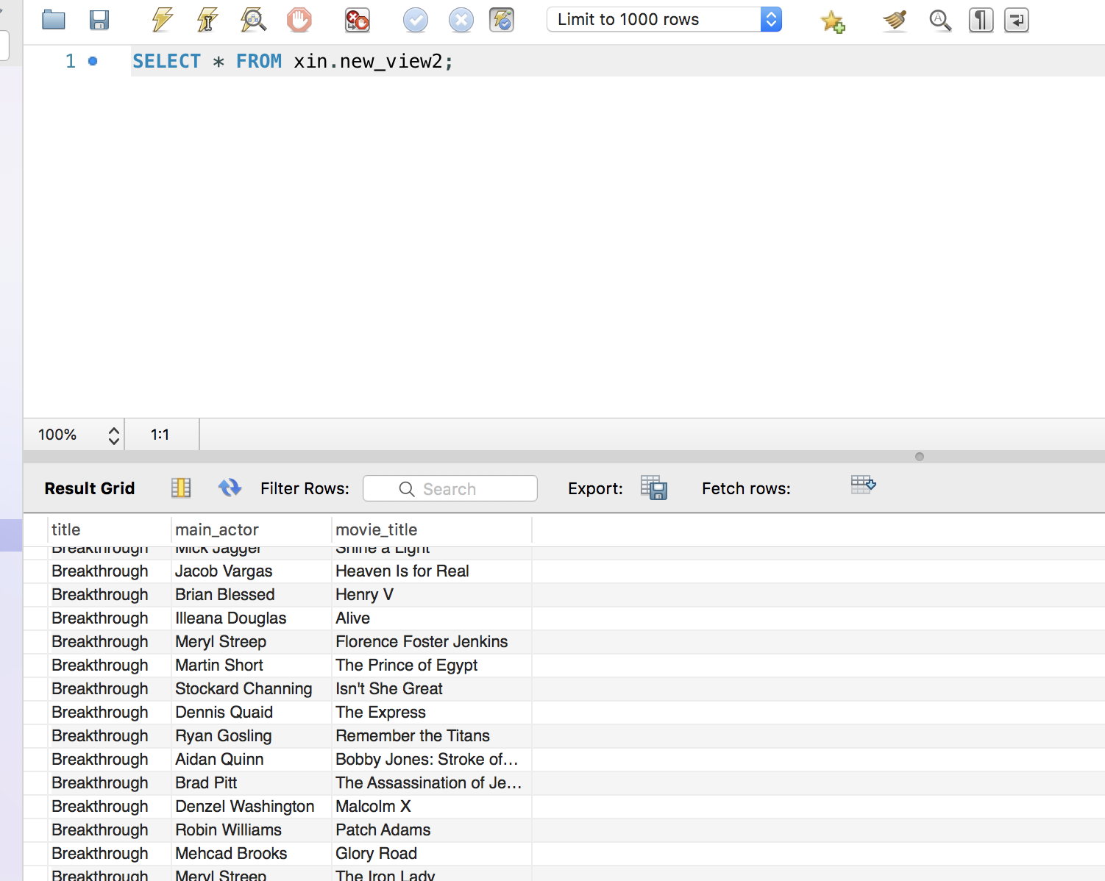

View3

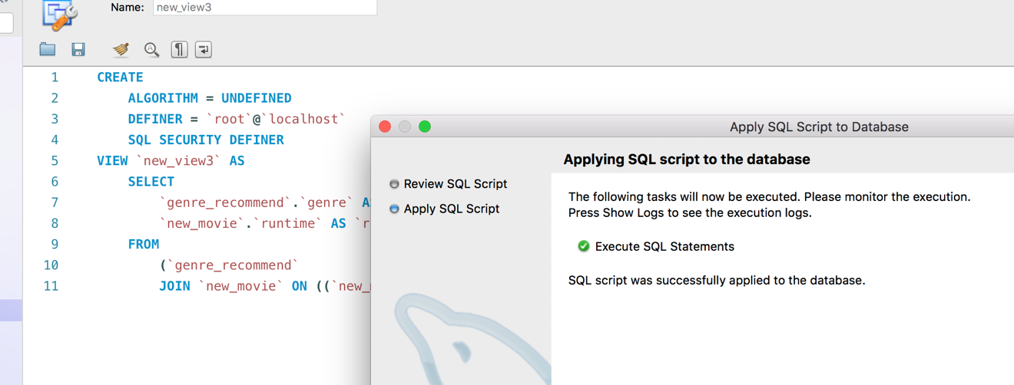

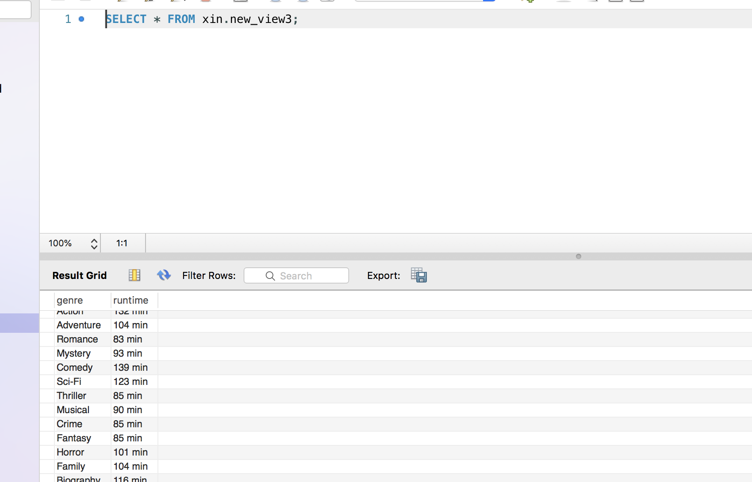

View4

